NAME: S.PRATIBA
ROLL No: 241901080

EXPERIMENT 4
DETECT SESSION HIJACKING

AIM:
To detect possible session hijacking by analysing network traffic and application logs using Wireshark and other security monitoring tools.

TOOLS REQUIRED:
- Kali Linux: Used as the monitoring machine for network traffic analysis.
- Metasploitable2: Used as the target machine in the isolated lab network.
- VirtualBox: Used to run both virtual machines.
- Wireshark: Used to capture and analyse ARP and ICMP packets.
- Terminal utilities: ping, arp -a, and ip neigh to verify connectivity and inspect IP-to-MAC address mappings.
- DVWA: Used in the lab to examine web session security, if required.

PROCEDURE:
- Start Kali Linux and Metasploitable2 in VirtualBox and ensure both machines are connected to the same isolated host-only network.
- Identify the IP addresses of the machines and verify connectivity using the ping command.
ping -c 4 192.168.56.102
- Open Wireshark in Kali Linux and start capturing network traffic on the eth0 interface.
- Apply the display filter arp to examine Address Resolution Protocol requests and replies.
- Apply the display filter icmp to observe ICMP echo requests and replies between Kali Linux and Metasploitable2.
- Inspect the ARP neighbour table using the following command:
ip neigh
Alternatively, use arp -a to view available IP-to-MAC address mappings.
- Compare the observed IP-to-MAC mappings and examine the captured traffic for unexpected or duplicate ARP replies that could indicate ARP spoofing.
- Record the captured packets, connectivity results, and ARP neighbour information, and document whether any session hijacking indicators were confirmed.

OBSERVATION:
TEST PPERFORMED | OBSERVATION
Checked IP addresses | Kali: 192.168.56.101;  Metasploitable2: 192.168.56.102
Tested connectivity using ping | 4 packets transmitted, 4 received, 0% packet loss.
Captured ARP packets using Wireshark | An ARP request asking for 192.168.56.100 was observed.
Analysed ICMP traffic | Echo requests and replies between Kali and Metasploitable2 were captured
Checked the ARP neighbour table using  ip neigh | Metasploitable2 was mapped to MAC address 08:00:27:07:0d:3c, with state STALE.
Checked for session hijacking indicators | No confirmed ARP spoofing or session hijacking was observed in the collected evidence.

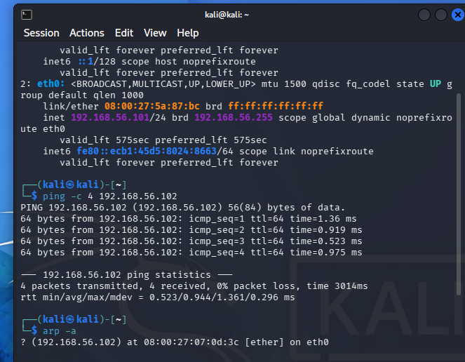
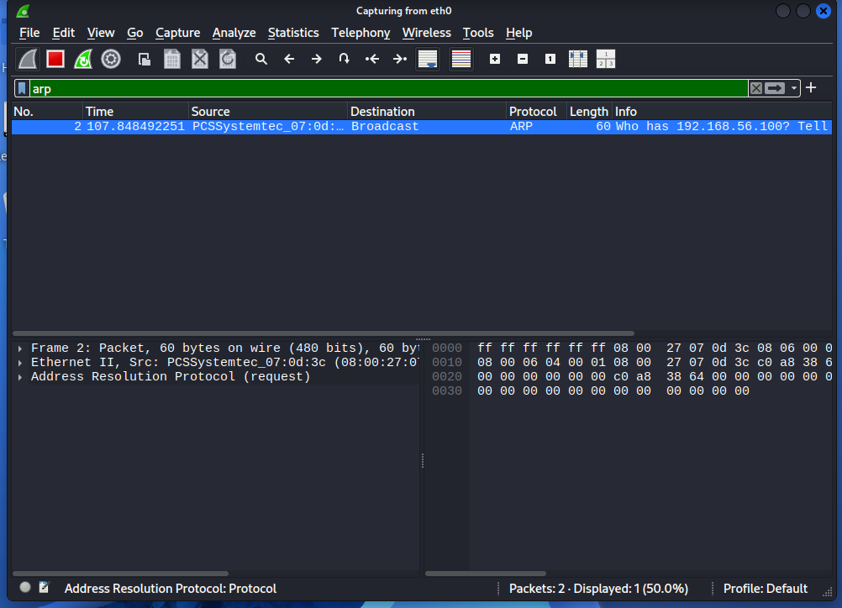
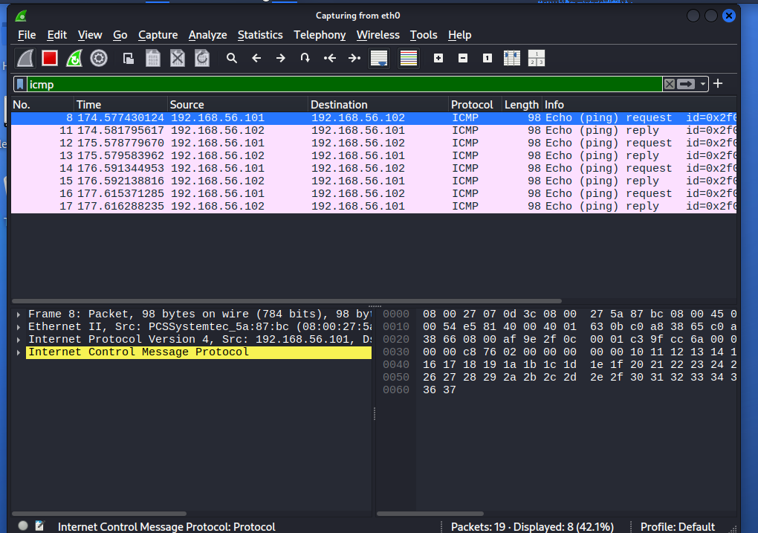
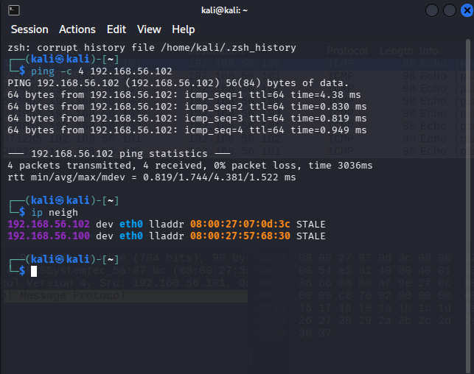
RESULT:
Network traffic was captured and analysed using Wireshark. Normal ARP requests and ICMP echo request/reply packets were observed. The ARP neighbour table was examined to understand IP-to-MAC address mapping and identify potential indicators of ARP spoofing. No session hijacking was confirmed during the observation.

